**Protein-macromolecule interactions heat dependence and machine learning**

251118 group discussion M1 Shunya Sudo

**Research Objectives**

　Our objective is to engineer composition-optimized random copolymers that form a compliant, chaperone-like shell around enzymes—primarily glucose oxidase (GOx) and, additionally, lipase (Lip)—to maximize thermal resistance without sacrificing native activity1. To form such a shell, protein–polymer interactions should be “strong enough to favor adsorption yet soft enough not to outcompete the forces governing protein folding.” 1 Because protein surfaces present chemical patches with characteristic length scales of ~1–2 nm, we prioritize controlling the statistical monomer distribution rather than the specific sequence in our polymer design1.

Operationally, we explore a ternary MPC/MTAC/BMA space tailored to GOx and use active ML: “five iterations of a Learn–Design–Build–Test cycle” with an enzyme-specific GPR surrogate and Bayesian optimization of copolymers to propose high-performing candidates that “preserve, or even enhance, the activity” after heating2.

We then generalize by substituting the hydrophobic unit (EHMA, LMA, MPTSSi) and leveraging Bayesian optimization as a proven alternative to high-throughput screening in polymer composition problems3.

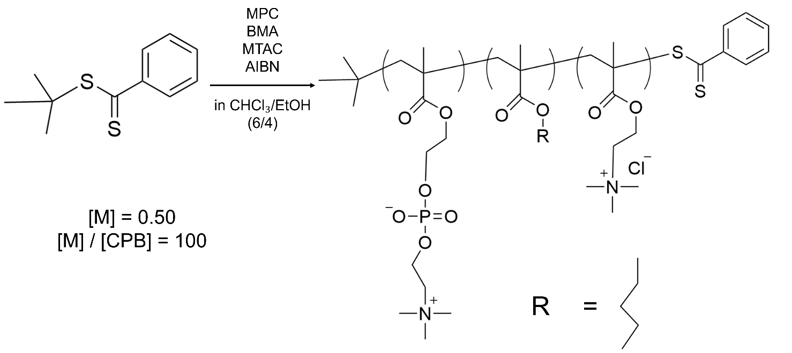

|  |  |  |  |  |  |  |  |  |
| --- | --- | --- | --- | --- | --- | --- | --- | --- |
|  |  |  | **Feed Ratio (mol %)** | | | **Composition Ratio (mol %)** | | |
|  | $$\frac{\left[BMA\right]}{\left[BMA\right]+ \left[MTAC\right]}$$ | $$\frac{\left[BMA\right]+ \left[MTAC\right]}{\left[MPC\right]+ \left[BMA\right]+ \left[MTAC\right]}$$ | **MPC** | **BMA** | **MTAC** | **MPC** | **BMA** | **MTAC** |
| PMBTA-1 | 0.2 | 0.2 | 80 | 4 | 16 | 84.4 | 2.5 | 13.1 |
| PMBTA-2 | 0.8 | 0.2 | 80 | 16 | 4 | 78.6 | 15.9 | 5.5 |
| PMBTA-3 | 0.2 | 0.7 | 30 | 14 | 56 | 30.4 | 14.2 | 55.4 |
| PMBTA-4 | 0.8 | 0.7 | 30 | 56 | 14 | 32.7 | 33.2 | 34.1 |
| PMBTA-5 | 0.5 | 0.45 | 55 | 22.5 | 22.5 | 50.3 | 22.4 | 22.4 |
| PMPC | - (0.5) | 0 | 100 | 0 | 0 | 100 | 0 | 0 |
| PMTAC | 0 | 1 | 0 | 0 | 100 | 0 | 0 | 100 |
| PMBTA-6 | 0.680 | 0.652 | 34.8 | 44.3 | 20.9 |  |  |  |
| PMBTA-7 | 0.773 | 0.877 | 12.3 | 67.8 | 19.9 |  |  |  |
| PMBTA-8 | 0.831 | 0.905 | 9.5 | 75.2 | 15.3 |  |  |  |
| PMBTA-9 | 0.858 | 0.621 | 37.9 | 53.3 | 8.8 |  |  |  |
| PMBTA-10 | 0.346 | 0.996 | 12.3 | 34.4 | 65.1 |  |  |  |
| PMBTA-11 | 0.981 | 0.627 | 37.3 | 61.5 | 1.2 |  |  |  |

**Summary of this report**

* Bayesian optimization (Rounds 1, 2, and 3)
* Synthesis of PMBTA-6, -7, -8, -9, -10, and -11
* Aggregation state and zeta potential of the copolymers
* Inter-round calibration in Bayesian optimization

1. **Reliability of the enzyme activity assay**

To evaluate the reliability of the thermal stability assay of GOx, the experiment was repeated three additional times under identical conditions.

* 1. **Experimental Methods**
     1. **Preparation of the enzyme solution**

1. GOx was dissolved in 0.1 mol/L phosphate buffer solution (pH 7.0) and adjusted to a concentration of 1.6 ng/mL.
2. The polymer was dissolved in EtOH and adjusted to a concentration of 4.0 mg/mL.
3. 25 µL of solution (2) was added to 2475 µL of solution (1).
4. The mixture was dispensed into 1.0 mL microtubes in 300 µL aliquots and incubated at 60 °C for 0, 5, 10, 15, 20, 40, and 60 min.
5. After heating, 100 µL of each sample was transferred into a 96-well microplate.
   * 1. **Preparation of the substrate solution**
6. D (+)-glucose was dissolved in 0.1 mol/L phosphate buffer solution (pH 7.0) and adjusted to a concentration of 0.01 mol/L.
7. HRP was dissolved in 0.1 mol/L phosphate buffer solution (pH 7.0) and adjusted to a concentration of 1 mg/mL.
8. To 19.8 mL of 0.1 mol/L phosphate buffer solution (pH 7.0), 20 mL of solution (1), 20 µL of solution (2), and 200 µL of Amplex Red solution were added.
   * 1. **Plate reader measurements**
9. The plate reader protocol was set to “GOx-resorufin-540/590” with the following conditions:

Interval: 0 s, Time: 30.

1. Using an 8-channel pipette, 100 µL of the substrate solution was rapidly added to each well, starting from the wells corresponding to the longest heating time.
2. The fluorescence of resorufin was measured.
3. The rate of increase in absorbance (slope obtained by fitting the initial linear region) was defined as the absolute activity.
   1. **Results**

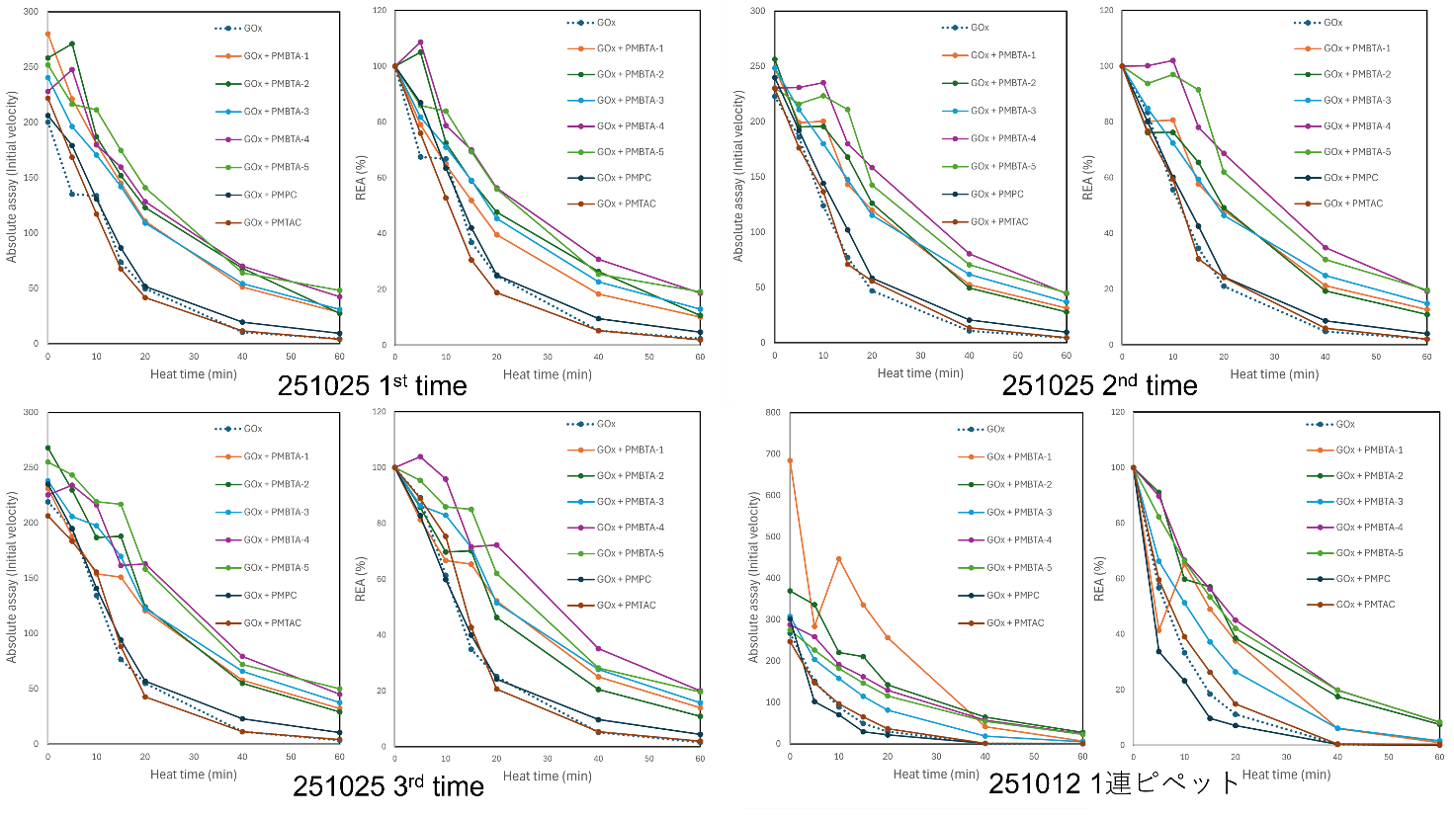

**Figure 1**. GOx assay with PMBTA (left: Absolute activity, right: Retain Enzyme Activity)

* For the three datasets acquired on 251025, similar trends were observed in all measurements.
  + From the standpoint of data reliability, no major issues are considered to be present.
* In the dataset acquired on 251012, only PMBTA-1 showed a notably higher absolute activity, which is a concern; however, the trend in relative enzymatic activity (REA) was almost identical to that in the other datasets.
* When homopolymers of PMPC or PMTAC were added, the activity of GOx showed almost no change.

1. **Bayesian optimization for GOx**

Bayesian optimization was performed on GOx activity.

* The objective function was the half-life, i.e., the time until the activity decreased to half of its initial value (to be maximized).
  + This objective could, in principle, be replaced by the residual activity after 20 min of heating, etc.
  + Because we collected time-course data at 5, 10, 15, 20, 40, and 60 min, we chose the time required for the activity to decrease to half its initial value as the objective.
  1. **Half-life of GOx activity**

On 251025, three independent datasets were acquired, and the half-life was calculated for each dataset.

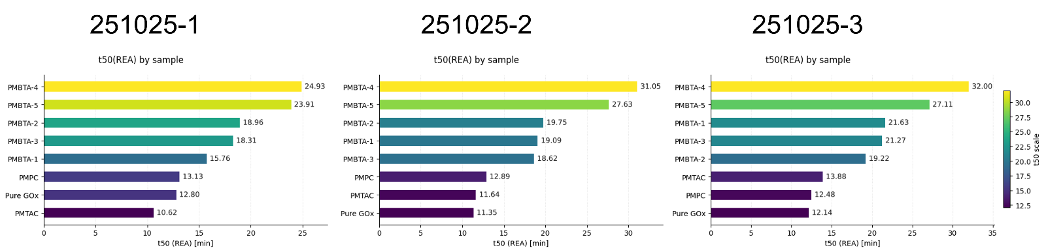

**Figure 2**. Half-life of GOx activity.

* PMBTA-4 and PMBTA-5 consistently ranked in the top two across all three measurements.
* In contrast, the rankings of PMPC, PMTAC, and pure GOx varied between measurements.
  + This indicates that PMPC and PMTAC do not significantly affect the thermal stability of GOx.

For the Bayesian optimization, dataset 251025-2 was used (**Figure 1**), because in this dataset the absolute activities in the unheated state (t = 0) were the most similar across all samples.

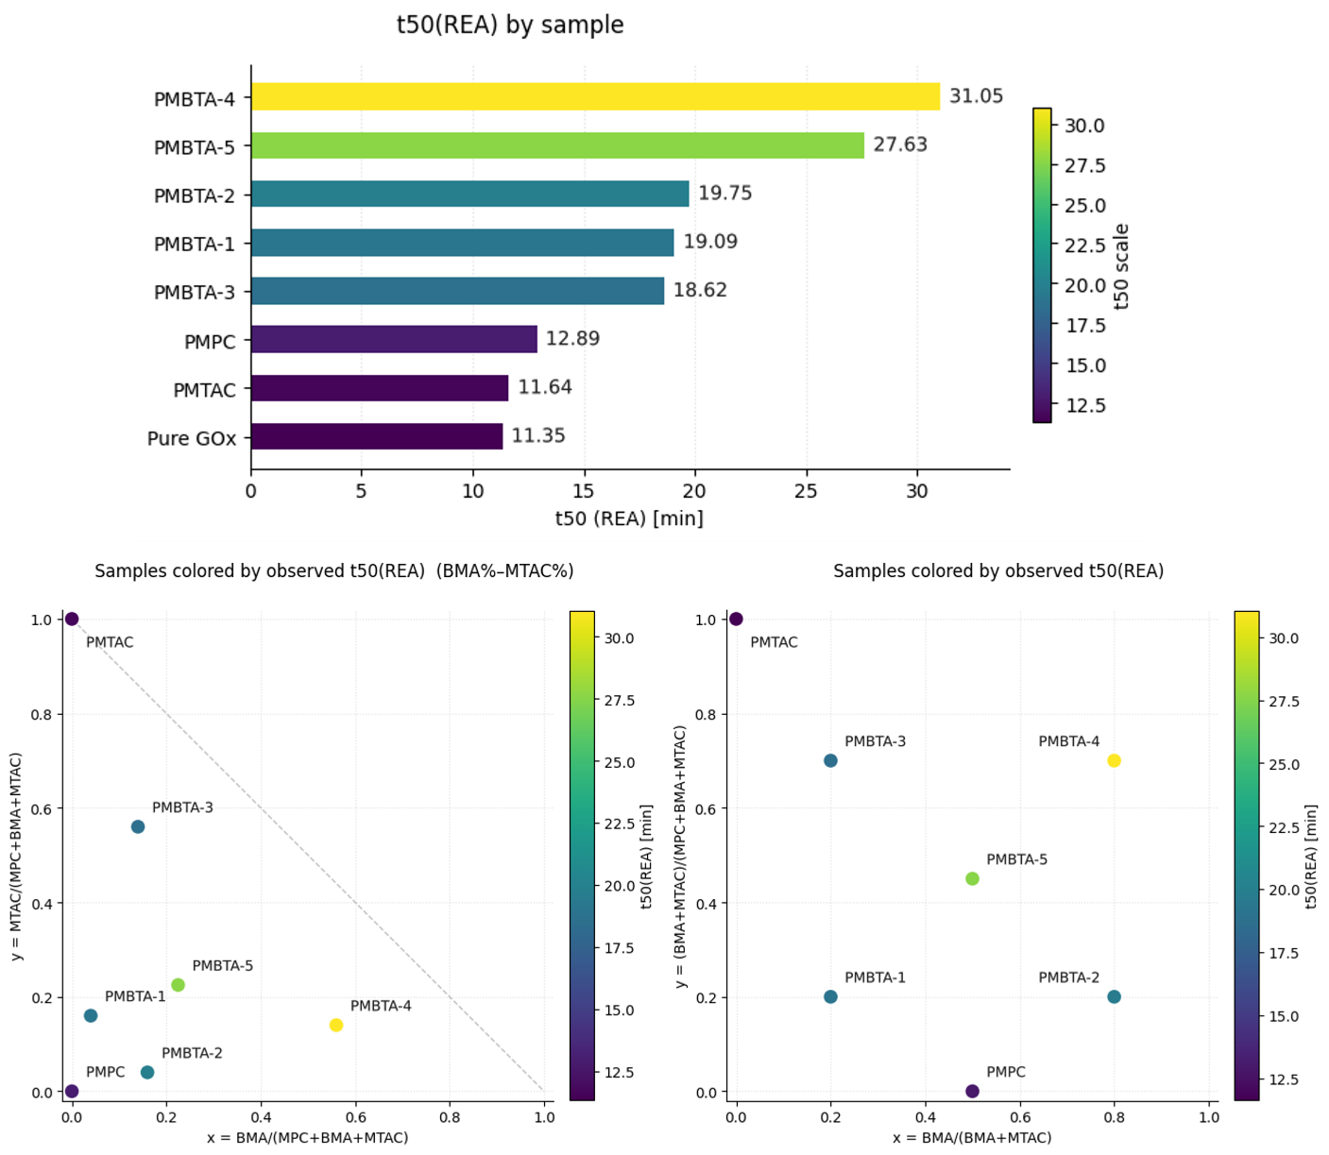

**Figure 3**. Half-life of GOx activity (left: bar chart, right: t50 map).

* 1. **目的変数の定義**

In this study, to suppress systematic differences between measurement rounds (plate-to-plate and day-to-day variability), we followed the approach of Tamasi et al., who normalized the enzyme activity (REA) in each assay as a ratio relative to the positive and negative controls (PC/NC-based standardization). In addition, we calculated the ratio of the t50 value relative to that of pure GOx measured in the same round (FoG = t50(sample)/t50(pure GOx)) to cancel out round-to-round scaling offsets. Tamasi et al. conducted their experiments over multiple iterations, and we similarly adopted round-wise normalization and model training in the present work.

FoG（Fold over GOx）: The fold change relative to the reference value of pure GOx (control) in the same round.

* （t50 is derived from the REA）: A value of 1.0 indicates the same thermal stability as pure GOx, and values greater than 1 indicate higher thermal stability.
* Pure GOx was measured in every round (RoundID) as an internal reference.

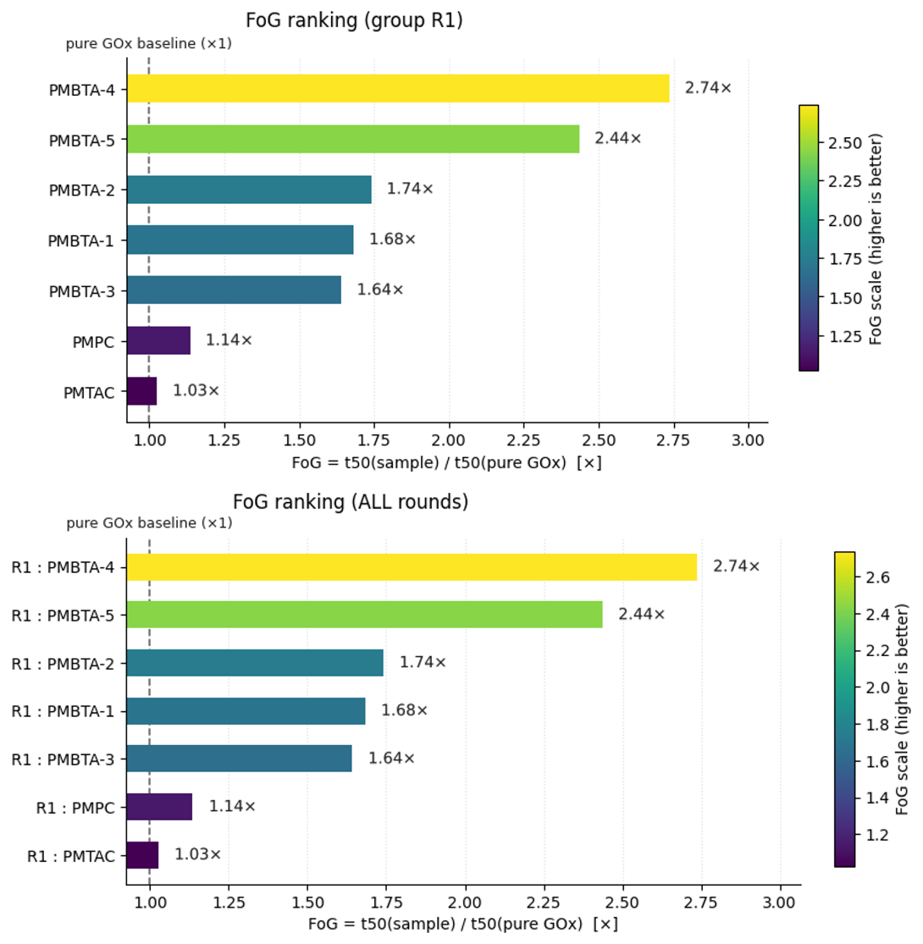

**Figure 4**. Fold over GOx for each polymer.

1. **Bayesian optimization (GOx, Round 2)**

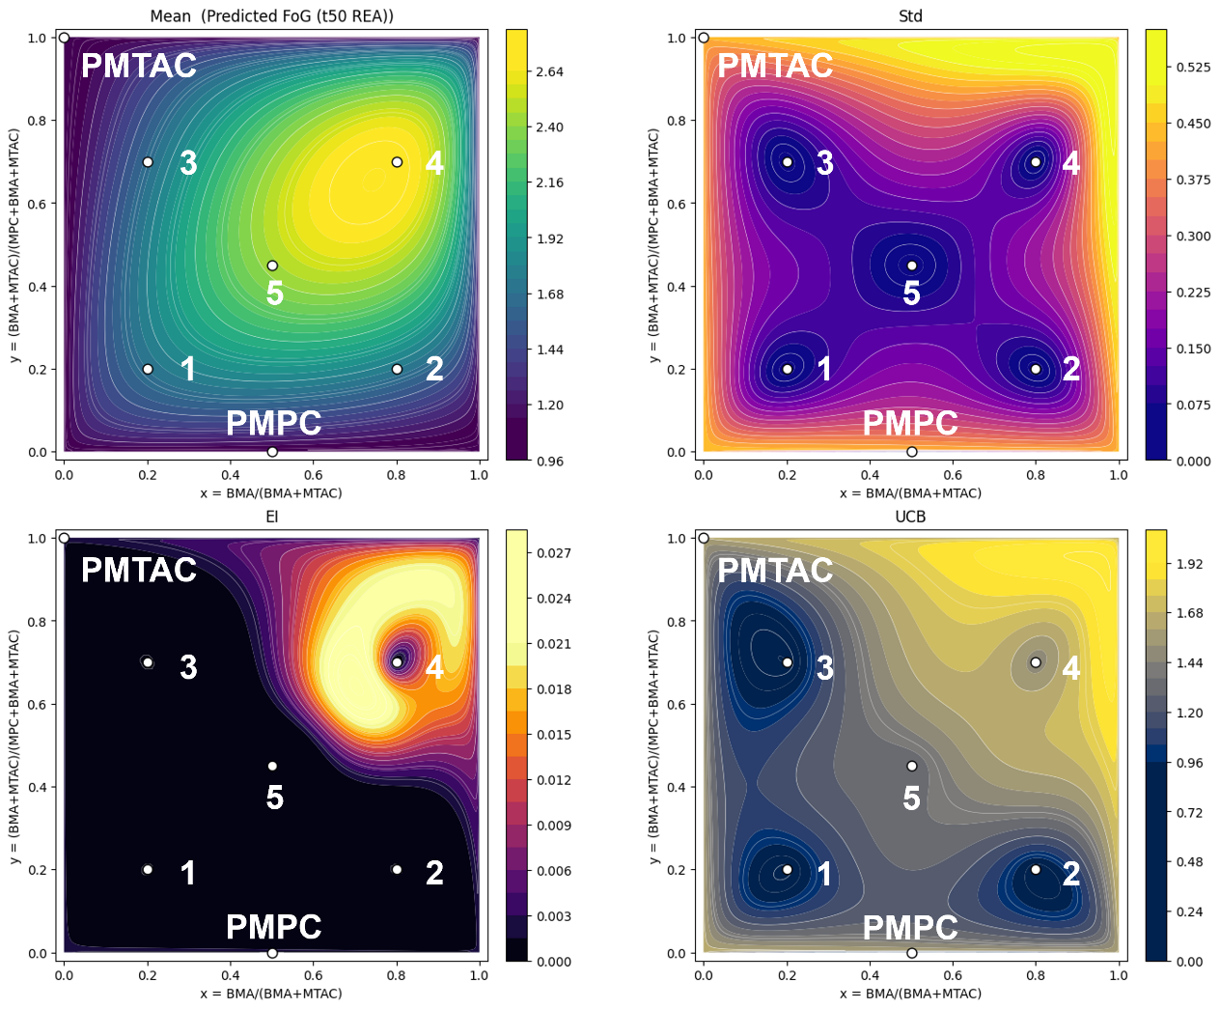

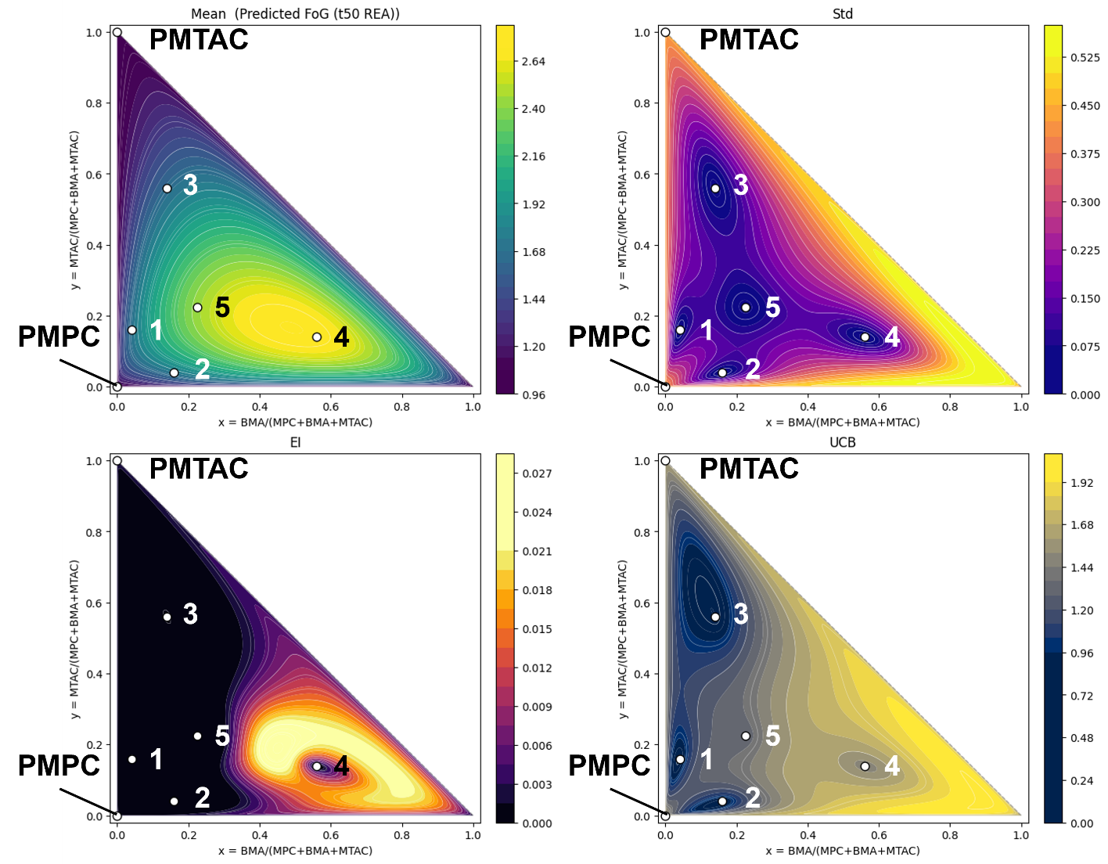

**Figure 5**. Bayesian surrogate and acquisition landscapes on the composition plane (Mean / Std / EI / UCB).

* Mean (μ):

The Gaussian Process (GP) surrogate’s predicted average of the objective (here, Predicted t50 (REA)). Think of it as the “performance map.”

* Std (σ):

The GP’s predictive standard deviation. This is uncertainty: small near data, large in unexplored areas or edges.

* EI (Expected Improvement):

Expected gain over the current best. It becomes large where μ is high *and* σ is non-negligible. Good for picking the “next best” experiments.

* UCB (Upper Confidence Bound):

μ + κσ (κ≈2.576 here). More exploratory: it rewards uncertain regions even if μ is modest.

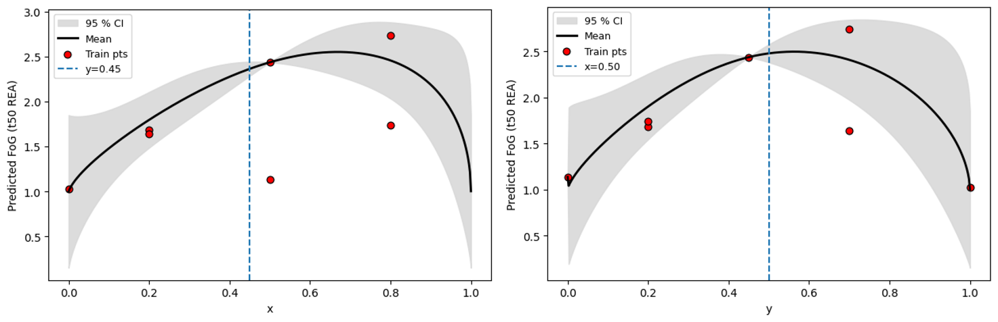

**Figure 6.** One-dimensional response profiles along composition axes (predictive mean with 95% CI).

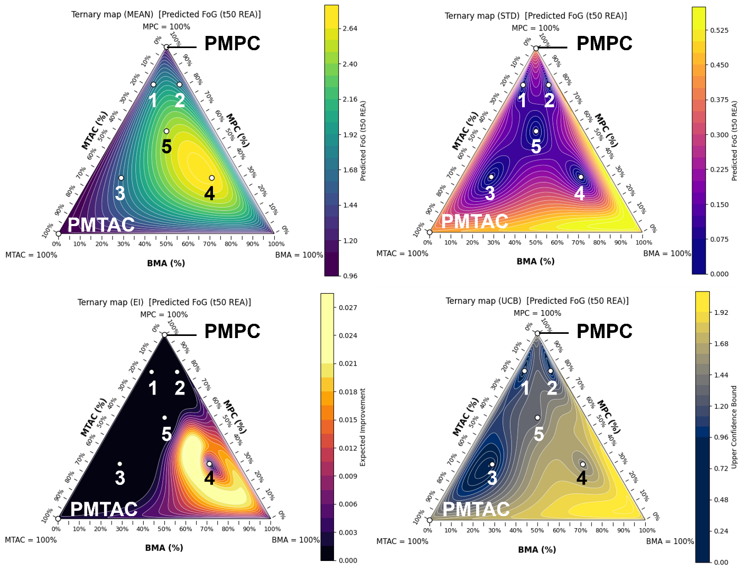

**Figure 7.** Ternary map of predicted performance across the MPC–MTAC–BMA space.

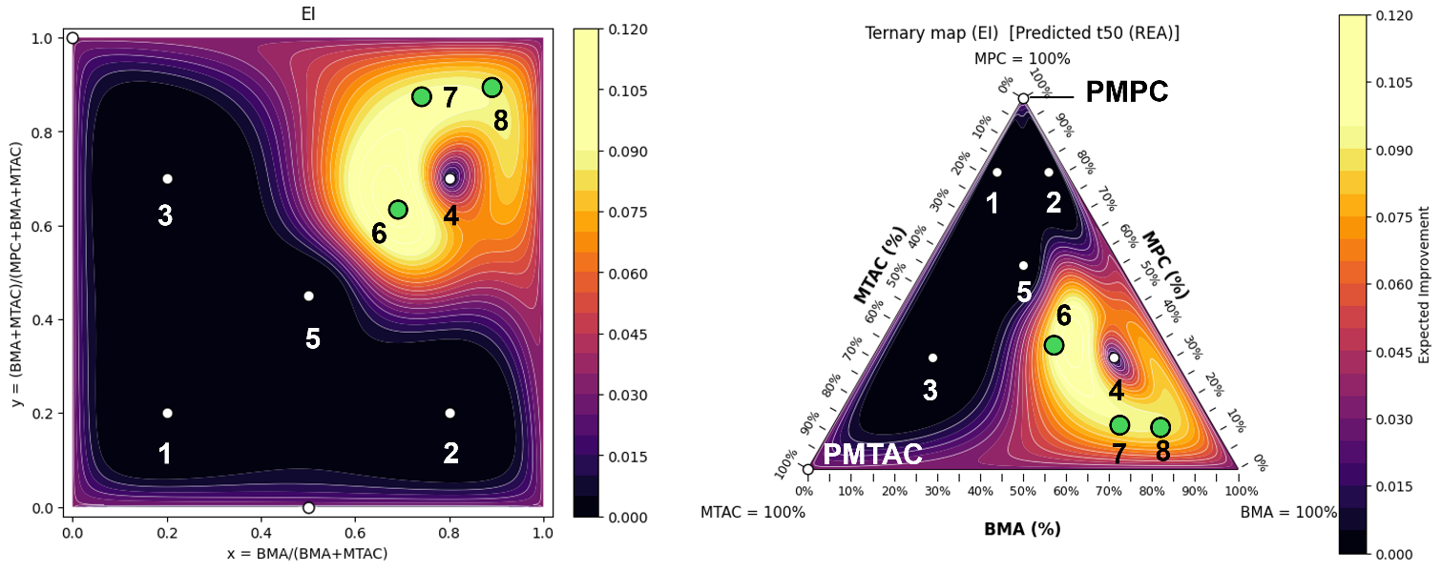

**Figure 8.** Mapping of candidates proposed by Bayesian optimization as having high EI

|  |  |  |  |  |  |
| --- | --- | --- | --- | --- | --- |
|  | $$x$$ | $$y$$ | **Feed Ratio (mol %)** | | |
|  | $$\frac{\left[BMA\right]}{\left[BMA\right]+ \left[MTAC\right]}$$ | $$\frac{\left[BMA\right]+ \left[MTAC\right]}{\left[MPC\right]+ \left[BMA\right]+ \left[MTAC\right]}$$ | **MPC** | **BMA** | **MTAC** |
| PMBTA-6 | 0.673 | 0.583 | 41.7 | 39.3 | 19.1 |
| PMBTA-7 | 0.629 | 0.749 | 25.1 | 47.2 | 27.8 |
| PMBTA-8 | 0.919 | 0.480 | 52.0 | 44.1 | 3.9 |

1. **Synthesis PMBTA-6, 7, 8**

The three compositions proposed by Bayesian optimization were synthesized.

* 1. **Experimental Methods**

1. 2-Methacryloyloxyethyl phosphorylcholine (MPC) (269 mg, 79.4 mol), [2-(methacryloyloxy)ethyl]trimethyl- ammonium chloride (MTAC) (43.9 mg, 9.1 mol), Butyl Methacrylate (BMA) (202 μL, 25.8 mol) were weighed and added to the test tube. The molar ratio was 4.17: 3.93: 1.91.
2. Solvent (CHCl3/EtOH = 6 / 4 mol) was added to 4ml test tube.
3. The test tube was stirred at 59°C to dissolve the ligand.
4. (4) 2-Cyanopropan benzodithioate-2-yl (CPB) (5mg, 0.0225mmol) and AIBN (α,α'-azobisisobutyronitrile) (2.5mg, 0.0152mmol) were weighed into a vial bottle. (2.5 mg, 0.0152 mmol) were weighed into a vial and dissolved in 500 μL of solvent, respectively.
5. The warmed test tubes were removed and nitrogen bubbling was performed for 10 minutes.
6. After 8minutes of nitrogen bubbling, 500 μL of the solution of (4) was added.
7. (6) After 7minutes of nitrogen bubbling, the tubes were sealed with parafilm and grease and allowed to react at 59°C for 24 hours in a constant-temperature water bath.
8. The reaction proceeded and the solution coagulated to a jelly-like state.
9. 3mL of solvent was added and dissolved by ultrasound and spatchera.
10. The solution was re-precipitated by adding to Solvent (Hexane / Diethyl ether = 3 / 1 )and collected on filter paper.
11. The polymer was collected by drying under reduced pressure for 24 hours.
12. **Measurement of particle size distribution**

　Particle size distribution was measured for each of PMBTA-6~8.

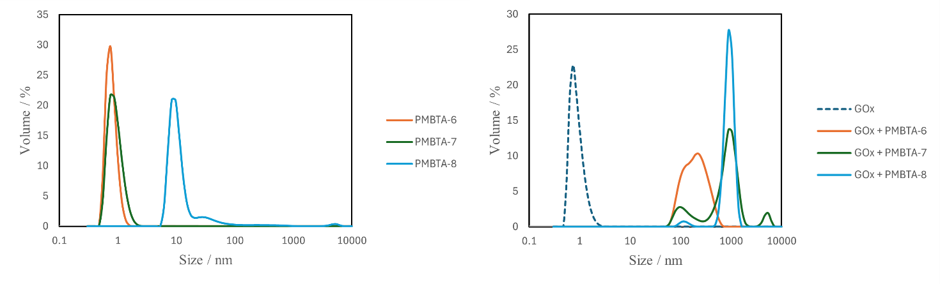

**Figure 9**. Particle size distribution of PMBTA (left: PMBTA6~8, right: GOx + PMBTA)

* The addition of GOx increased the overall particle size.

1. **Measurement of zeta potential**

Zeta potentials were measured using PMBTA solutions at 3 mg/mL. For the GOx + PMBTA mixtures, the concentrations of GOx and PMBTA were each 1.5 mg/mL.

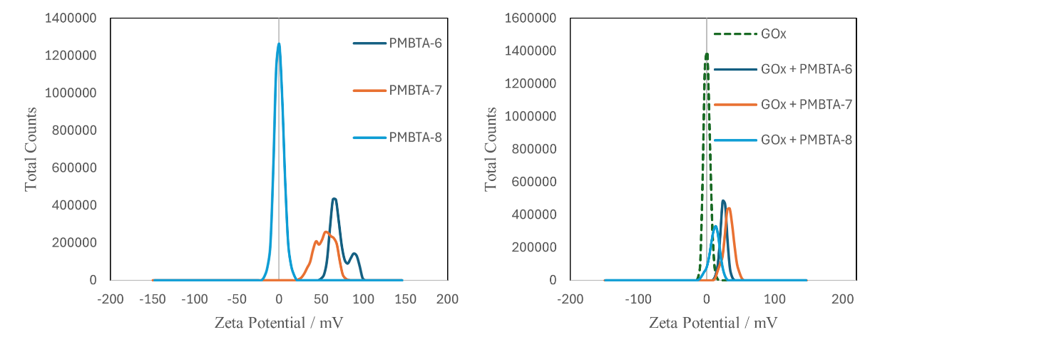

**Figure 10**. Zeta potential of PMBTA (left: PMBTA6~8, right: GOx + PMBTA)

* In the GOx + PMBTA mixtures, the zeta potential values followed the order of the MTAC composition ratio.
* For PMBTA alone, the zeta potential data for PMBTA-6 and PMBTA-7 were not very clean (noisy and less reliable).

1. **Enjzyme Assay (GOx)**

The thermal stability of GOx upon heating in the presence of PMBTA was investigated.

All copolymers that had been evaluated in the previous round were re-measured for comparison.

Concentration GOx: 0.0016 mg/mL, Polymer: 0.025 mg/mL, Temperature: 60℃, Time: 60 min

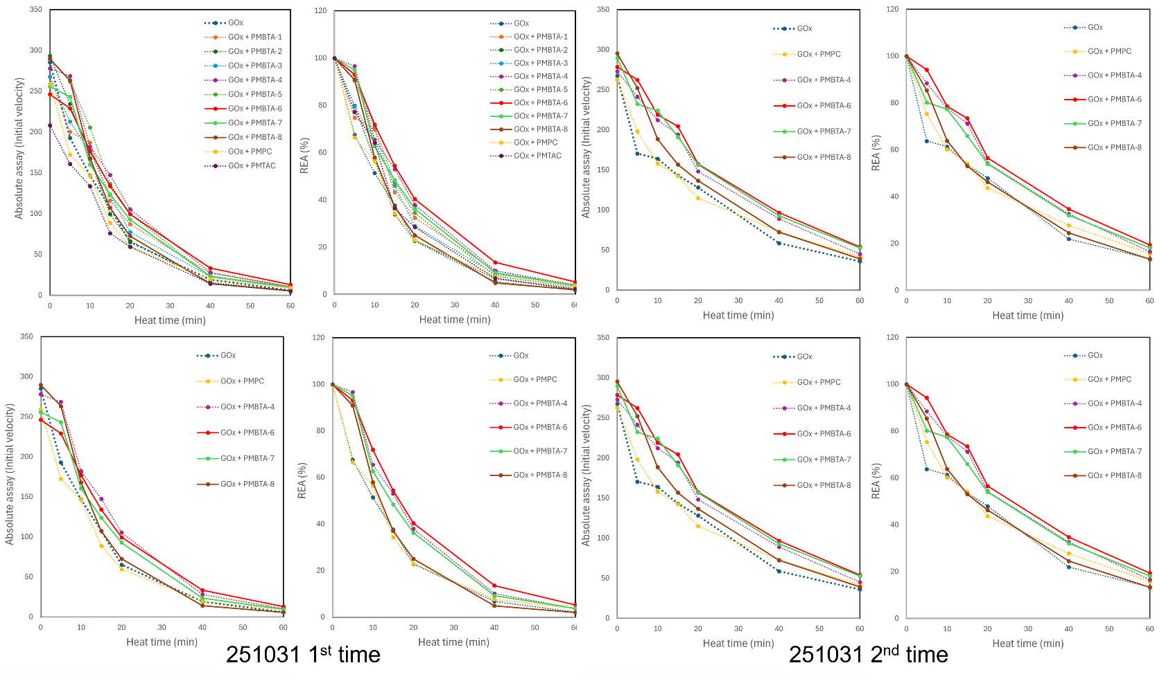**Figure 11**. GOx assay with PMBTA (left: Absolute activity, right: Retain Enzyme Activity) (251031).

* PMBTA-4 and PMBTA-6 showed the highest thermal stability, followed by PMBTA-7.
* PMPC and PMTAC did not significantly affect the thermal stability of GOx.

1. **Bayesian optimization**

Bayesian optimization was performed on GOx activity.

* The objective function was FoG, defined as how much longer the half-life (time until the activity decreases to half of its initial value) is compared with pure GOx.
  + Because systematic differences arise between rounds, data for copolymers that were measured in multiple rounds were used to calibrate (correct) the round-to-round variation.
  1. **Correction of round-to-round measurement error (anchor correction)**

　Because enzymes are highly sensitive, even slight differences in concentration and other factors that cannot be perfectly controlled by the experimenter inevitably introduce errors. These errors are relatively small when samples are measured simultaneously in the same batch, but they become much more pronounced when measurements are carried over to a different round (different plate/day).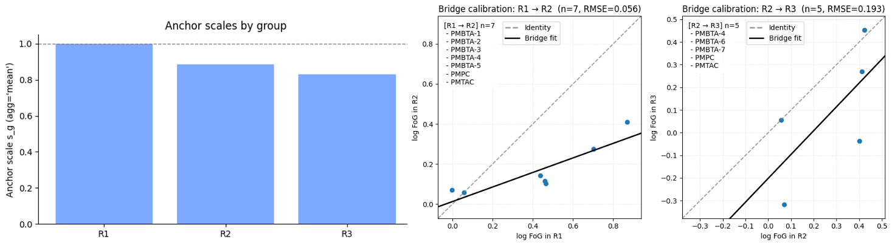

**Figure 12**. Anchor-based cross-round calibration of FoG.

(Left: Anchor scale factors $s_{g}$ for each round (R1–R3), calculated as the mean FoG ratio of copolymers measured in common across adjacent rounds, with R1 fixed to $s_{R1}=1.0$.  
Middle and right: Bridge calibration plots of log FoG between R1 and R2 (n = 7) and between R2 and R3 (n = 5), respectively. Each point represents a common copolymer; the grey dashed line indicates the identity line ($y=x$), and the black solid line shows the best linear “bridge” fit used to check the appropriateness of the multiplicative scale correction.)

* When moving to the next round, the top‐ranked and bottom‐ranked PMBTA from the previous round were always carried over.
* This allows us to correct and compare the performance of the same copolymers when their behavior differs across rounds.
  + 1. **Calculation of the anchor correction scale $s_{R}$**

1. Metric
   * For inter-round calibration, we used the logarithm of the objective function FoG (log FoG).
2. Extraction of common copolymers (“anchors”)
   * For each round $R$ and the subsequent round $R^{'}$, copolymers measured in both rounds (e.g., PMBTA-1–5, PMPC, PMTAC, etc.) were extracted as “anchors”.
3. Estimation of the average offset between rounds
   * Let $A_{R,R^{'}}$ denote the set of anchors between rounds $R$ and $R^{'}$. For each anchor $i∈A_{R,R^{'}}$, we computed

$$d_{i}=log⁡({FoG}_{R^{'},i})-log⁡({FoG}_{R,i})$$

and then took the average

$$Δ_{R→R^{'}}=\frac{1}{∣A_{R,R^{'}}∣}\sum_{i∈A_{R,R^{'}}}{d_{i}}$$

This represents the average shift in log FoG for the same copolymer when going from round $R$ to round $R^{'}$.

1. Determination of the round-wise scale factor $s_{R}$
   * Taking R1 as the reference, we fixed $s_{R1}=1$.
   * For each transition R1→R2, R2→R3, …, we computed

$$k_{R→R^{'}}=exp⁡(Δ_{R→R^{'}})$$

and propagated the scale factors as

$$s_{R^{'}}=s_{R}⋅k_{R→R^{'}}$$

In the present dataset, the resulting scale factors were:

$$s_{R1}=1.0$$

$$s_{R2}=0.89$$

$$s_{R3}=0.83$$

1. Practical correction

* For all samples in each round $R$, the corrected FoG values were obtained as

$$log⁡({FoG}_{R,i}^{corr})=log⁡({FoG}_{R,i}^{raw})-log⁡(s_{R})$$

（すなわち ${FoG}_{R,i}^{corr}=\frac{{FoG}_{R,i}^{raw}}{s_{R}}$）  
This transformation aligned the scales such that the log FoG values of the anchor copolymers agreed on average across rounds.

Figure 12 shows the bar chart of the anchor-corrected round-wise scale factors and the bridge calibration plot for log FoG. In the bar chart, $s_{R1}=1.0$ is fixed, and the scale factor for each round indicates how the overall level of FoG in that round compares with R1. From these results, we found that R1 tended to give systematically higher FoG values, whereas the values in R2 and R3 were slightly lower. Therefore, the FoG values of copolymers measured in R2 and R3 were corrected so that they could be compared on the same scale as R1, by multiplying the R2 data by $1/0.89$ and the R3 data by $1/0.83$, respectively.

* + 1. **Bridge calibration**

Figure 12 thus visualizes “how much the FoG values for copolymers measured in common differ between rounds.”

* + - 1. **Overall meaning of the plots**

Taking the R1 → R2 panel in Figure 12 as an example:

* Horizontal axis: $x=log⁡({FoG}_{R1})$
* Vertical axis: $y=log⁡({FoG}_{R2})$

Only the copolymers measured in both rounds are plotted, and on top of these points we draw:

* A gray dashed line: $y=x$ (the ideal identity line where FoG agrees perfectly between rounds),
* A black solid line: $y=ax+b$ (the least-squares fit to the actual data),
* The RMSE in the title: the root-mean-square deviation from this black regression line.

In this setting,

$$y=ax+b⟺log⁡{FoG}_{\text{to}}=alog⁡{FoG}_{\text{from}}+b$$

so after exponentiation we obtain

$${FoG}_{\text{to}}≈e^{b} {FoG}_{\text{from}}^{ a}$$

Thus, the bridge calibration plot is mainly used to check:

1. Whether there is a simple multiplicative offset between rounds (dominant effect of $b$),
2. Whether the “contrast” in the ranking has changed (dominant effect of $a$),
3. Whether both effects are present, or whether the differences are dominated by noise (RMSE and scatter).
   * + 1. **Interpretation of the slope $a$**

Case $a≈1$

* ${FoG}_{\text{to}}≈e^{b}×{FoG}_{\text{from}}$ ⇒The multiplicative factor is almost constant, so the relative ranking (“better vs. worse” samples) is essentially preserved when moving from one round to the next.
* The difference between rounds can be interpreted mainly as a global upward/downward shift of all values.

Case $a<1$

* ${FoG}_{\text{to}}≈{FoG}_{\text{from}}^{a}$（※assuming b ≈ 0）
* A slope < 1 on the log–log plot means that the dynamic range is compressed in the “to” round: differences that were large in R1 appear “flattened” in R2.
* In other words, the gap between the “very good” samples and the “moderately good” samples becomes smaller in the subsequent round.

Case $a>1$

* The opposite situation: differences are amplified and the dynamic range expands in the “to” round, so performance gaps between samples become more pronounced.
  + - 1. **Interpretation of the intercept $b$**

Case $b≈0$

${FoG}_{\text{to}}≈{FoG}_{\text{from}}^{a}$

* The point $FoG=1$ (i.e., $log⁡FoG=0$) appears at almost the same position in both rounds.
* This indicates that the “moderate” activity level relative to the control is unchanged, and the main difference between rounds lies in the contrast parameter $a$.

Case $b>0$

* The entire relationship is shifted upward: all copolymers are in an “overall boosted” state.
* Conceptually, FoG is uniformly increased by a factor of $e^{b}$ across samples.

Case $b<0$

* The opposite: FoG values are uniformly decreased, meaning that all samples appear systematically worse in the “to” round.
  + - 1. **Interpretation of Figure 12**

(1) R1 → R2 panel

* The slope of the black regression line, $a$, is clearly less than 1.
* The intercept $b$ is very close to 0.
* Near the origin, the points lie roughly along $y≈x$, but for larger FoG values (better samples), the points fall below the identity line.

→ Interpretation:

1. “Average to moderately good” samples show little difference in absolute level between R1 and R2 (because $b≈0$, FoG values near 1 do not shift much).
2. The “very good” samples, however, appear less outstanding in R2 ( $a<1$ → compressed dynamic range).

In other words:

* In R1, the differences between the top-performing samples and the others are somewhat exaggerated.
* In R2, the same differences look milder.

This suggests that the sensitivity or effective dynamic range of the assay changed between rounds, leading to a compression of performance differences among the top-ranked samples.

(2) R2 → R3 panel

* The slope $a$ is close to 1.
* The entire regression line is shifted below the identity line, with a slightly negative intercept $b$ around $-0.2$.
* The RMSE is larger than in the R1 → R2 panel, indicating somewhat greater scatter.

→ Interpretation：

1. Because $a≈1$, the “contrast” (how strongly differences between samples are expressed) is largely preserved between R2 and R3; the ranking of good and poor samples is mostly maintained.
2. At the same time, $b<0$ indicates that all copolymers tend to show lower FoG values in R3 than in R2; the overall level has dropped.

Written explicitly,

$$log⁡{FoG}_{R3}≈log⁡{FoG}_{R2}+b,b<0 \\ ⇒{FoG}_{R3}≈e^{b} {FoG}_{R2}$$

and since $e^{b}<1$, this corresponds to a uniform degradation by a constant factor across samples.

1. **Bayesian optimization (GOx, Round 2)**

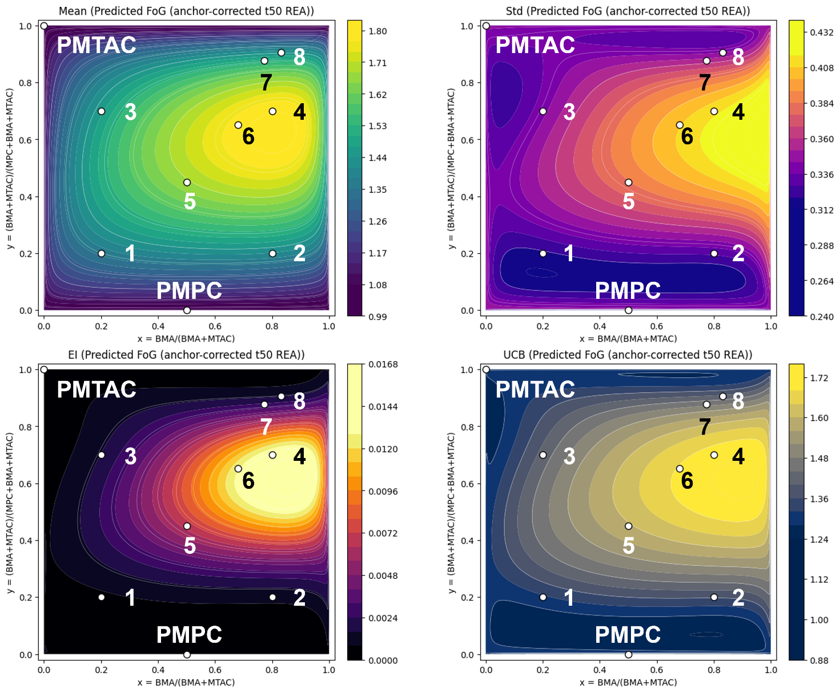

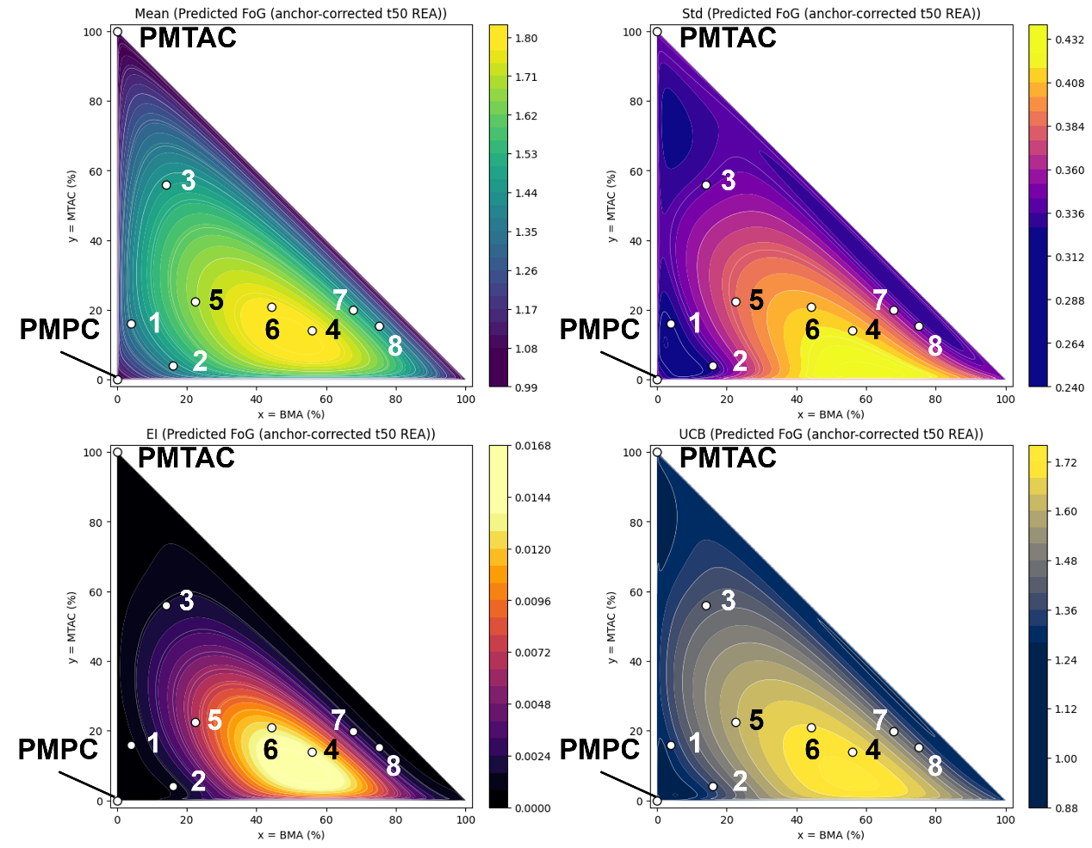

**Figure 13**. Bayesian surrogate and acquisition landscapes on the composition plane (Mean / Std / EI / UCB).

* Mean (μ):

The Gaussian Process (GP) surrogate’s predicted average of the objective (here, Predicted t50 (REA)). Think of it as the “performance map.”

* Std (σ):

The GP’s predictive standard deviation. This is uncertainty: small near data, large in unexplored areas or edges.

* EI (Expected Improvement):

Expected gain over the current best. It becomes large where μ is high *and* σ is non-negligible. Good for picking the “next best” experiments.

* UCB (Upper Confidence Bound):

μ + κσ (κ≈2.576 here). More exploratory: it rewards uncertain regions even if μ is modest.

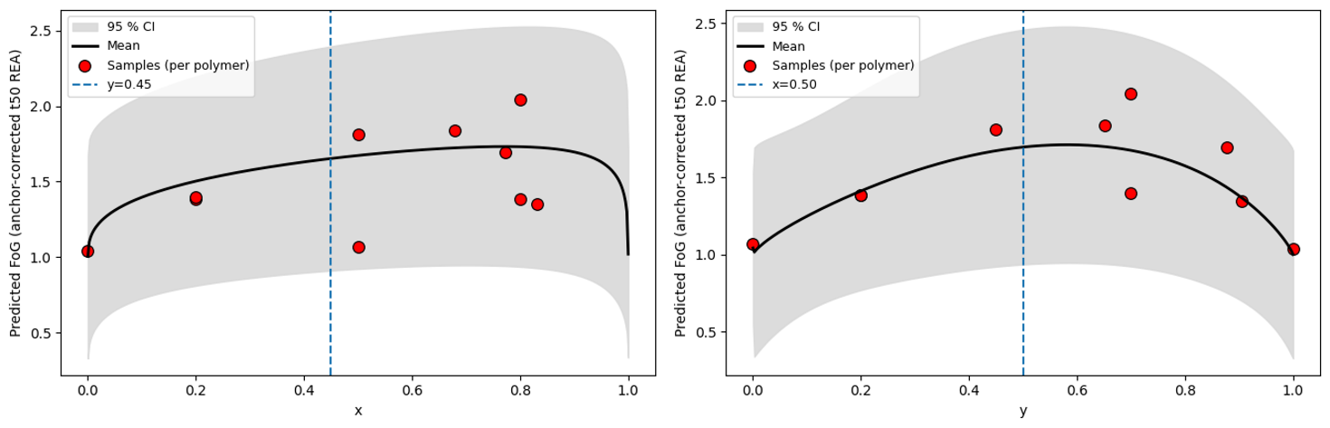

**Figure 14.** One-dimensional response profiles along composition axes (predictive mean with 95% CI).

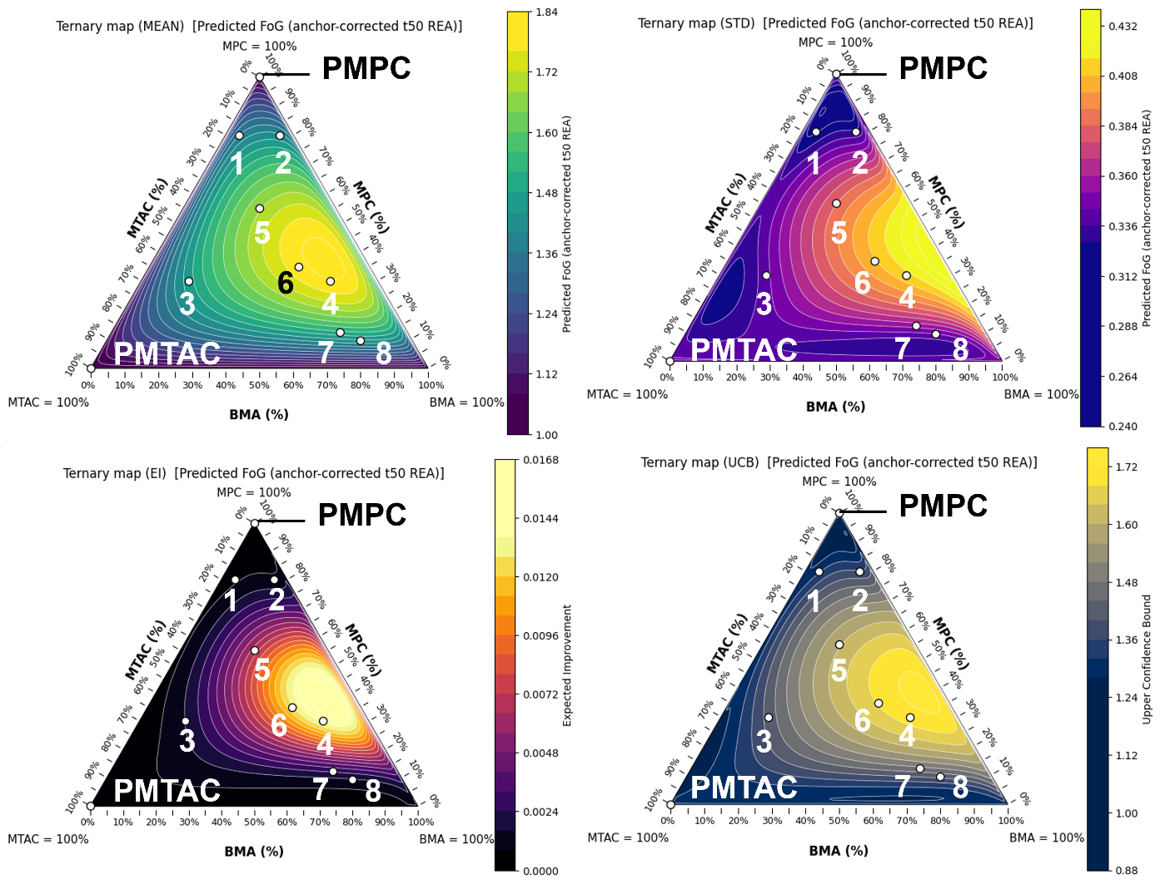

**Figure 15.** Ternary map of predicted performance across the MPC–MTAC–BMA space.

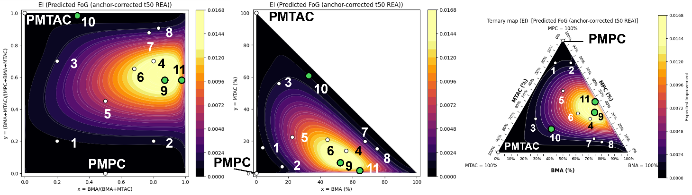

**Figure 16.** Mapping of candidates proposed by Bayesian optimization as having high EI

|  |  |  |  |  |  |
| --- | --- | --- | --- | --- | --- |
|  | $$x$$ | $$y$$ | **Feed Ratio (mol %)** | | |
|  | $$\frac{\left[BMA\right]}{\left[BMA\right]+ \left[MTAC\right]}$$ | $$\frac{\left[BMA\right]+ \left[MTAC\right]}{\left[MPC\right]+ \left[BMA\right]+ \left[MTAC\right]}$$ | **MPC** | **BMA** | **MTAC** |
| PMBTA-9 | 0.858 | 0.621 | 37.9 | 53.3 | 8.8 |
| PMBTA-10 | 0.346 | 0.996 | 12.3 | 34.4 | 65.1 |
| PMBTA-11 | 0.981 | 0.627 | 37.3 | 61.5 | 1.2 |

1. **Synthesis PMBTA-9, 10, 11**

The three compositions proposed by Bayesian optimization were synthesized.

* 1. **Experimental Methods**

1. 2-Methacryloyloxyethyl phosphorylcholine (MPC) (243 mg, 71.8 mol), [2-(methacryloyloxy)ethyl]trimethyl- ammonium chloride (MTAC) (102.7 mg, 21.3 mol), Butyl Methacrylate (BMA) (165.6 μL, 21.2mol) were weighed and added to the test tube. The molar ratio was 3.48: 2.09: 4.43.
2. Solvent (CHCl3/EtOH = 6 / 4 mol) was added to 4ml test tube.
3. The test tube was stirred at 59°C to dissolve the ligand.
4. (4) 2-Cyanopropan benzodithioate-2-yl (CPB) (5mg, 0.0225mmol) and AIBN (α,α'-azobisisobutyronitrile) (2.5mg, 0.0152mmol) were weighed into a vial bottle. (2.5 mg, 0.0152 mmol) were weighed into a vial and dissolved in 500 μL of solvent, respectively.
5. The warmed test tubes were removed and nitrogen bubbling was performed for 10 minutes.
6. After 8minutes of nitrogen bubbling, 500 μL of the solution of (4) was added.
7. (6) After 7minutes of nitrogen bubbling, the tubes were sealed with parafilm and grease and allowed to react at 59°C for 24 hours in a constant-temperature water bath.
8. The reaction proceeded and the solution coagulated to a jelly-like state.
9. 3mL of solvent was added and dissolved by ultrasound and spatchera.
10. The solution was re-precipitated by adding to Solvent (Hexane / Diethyl ether = 3 / 1) and collected on filter paper.
11. The polymer was collected by drying under reduced pressure for 24 hours.
12. **Measurement of particle size distribution**

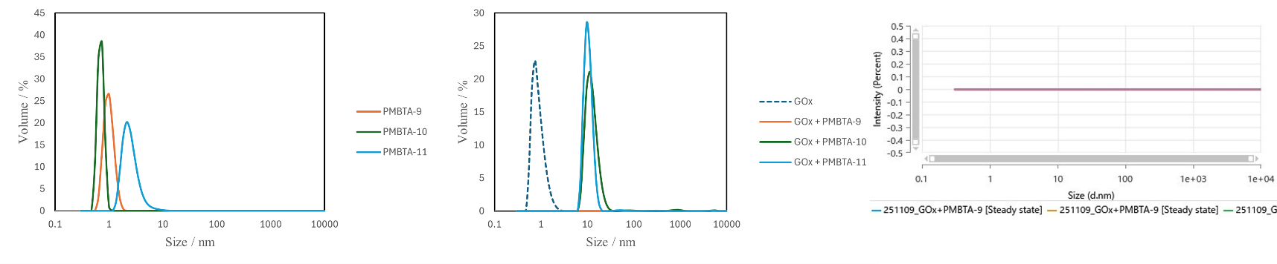　Particle size distribution was measured for each of PMBTA-6~8.

**Figure 17**. Particle size distribution of PMBTA (left: PMBTA-9~11, right: GOx + PMBTA)

* For PMBTA-9, the GOx + PMBTA-9 sample was measured three times, but no detectable signal was obtained.
  + It will be necessary to consider whether this is due to some specific inhibitory mechanism or simply experimental contingency.
  + Given that its thermal stability does not appear to be particularly high, it is questionable whether further in-depth analysis of PMBTA-9 is worthwhile.
* For PMBTA-10 and PMBTA-11, the results suggest that, when coexisting with GOx, these copolymers tend to aggregate around the enzyme.

1. **Measurement of zeta potential**

Zeta potentials were measured using PMBTA solutions at 3 mg/mL. For the GOx + PMBTA mixtures, the concentrations of GOx and PMBTA were each 1.5 mg/mL.

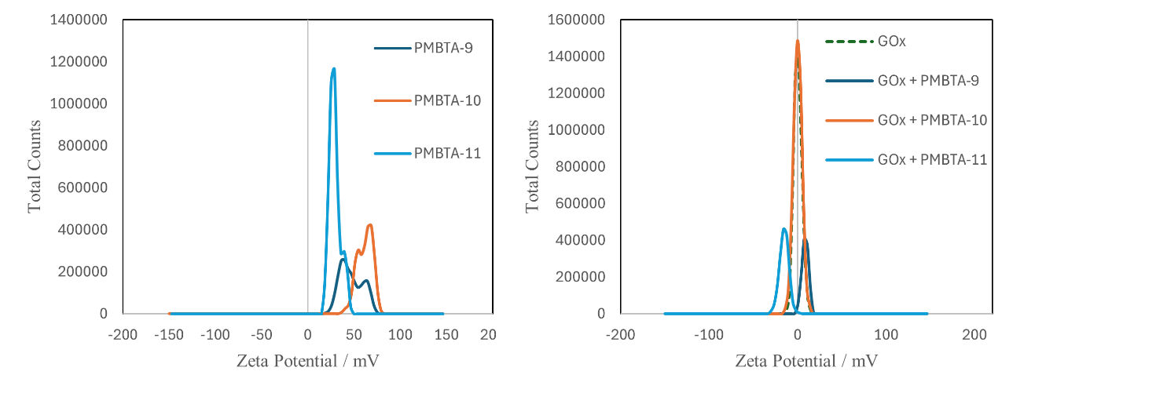

**Figure 18**. Zeta potential of PMBTA (left: PMBTA6~8, right: GOx + PMBTA)

* For PMBTA alone, the zeta potential increased in magnitude in accordance with the MTAC composition (higher MTAC content led to higher zeta potential).
* For the GOx + PMBTA mixtures, the zeta potential of PMBTA-11 shifted to a negative value.

1. **Enjzyme Assay (GOx, Round 3)**

The thermal stability of GOx upon heating in the presence of PMBTA was then evaluated

Concentration GOx: 0.0016 mg/mL, Polymer: 0.025 mg/mL, Temperature: 60℃, Time: 60 min

For comparison, the top- and bottom-performing copolymers from the previous round were also re-measured under the same conditions.

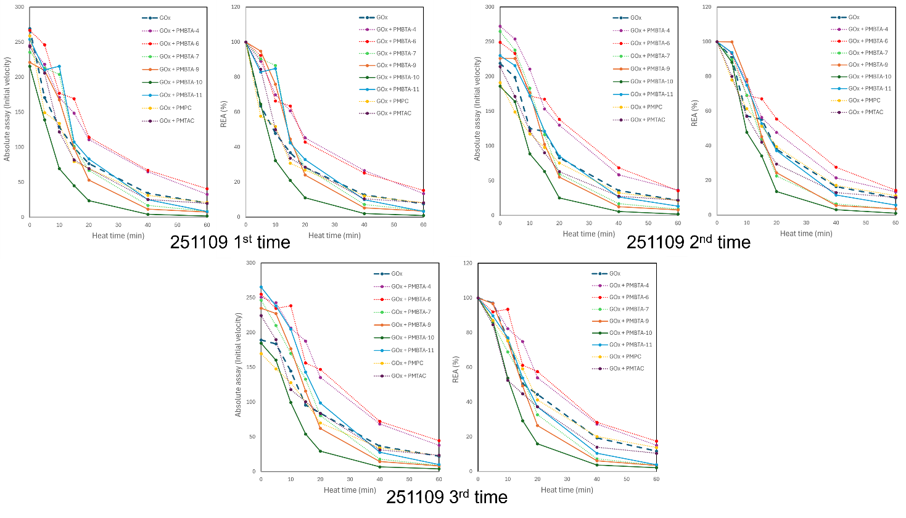**Figure 19**. GOx assay with PMBTA (left: Absolute activity, right: Retain Enzyme Activity) (251109).

1. **Bayesian optimization (GOx, Round 3)**

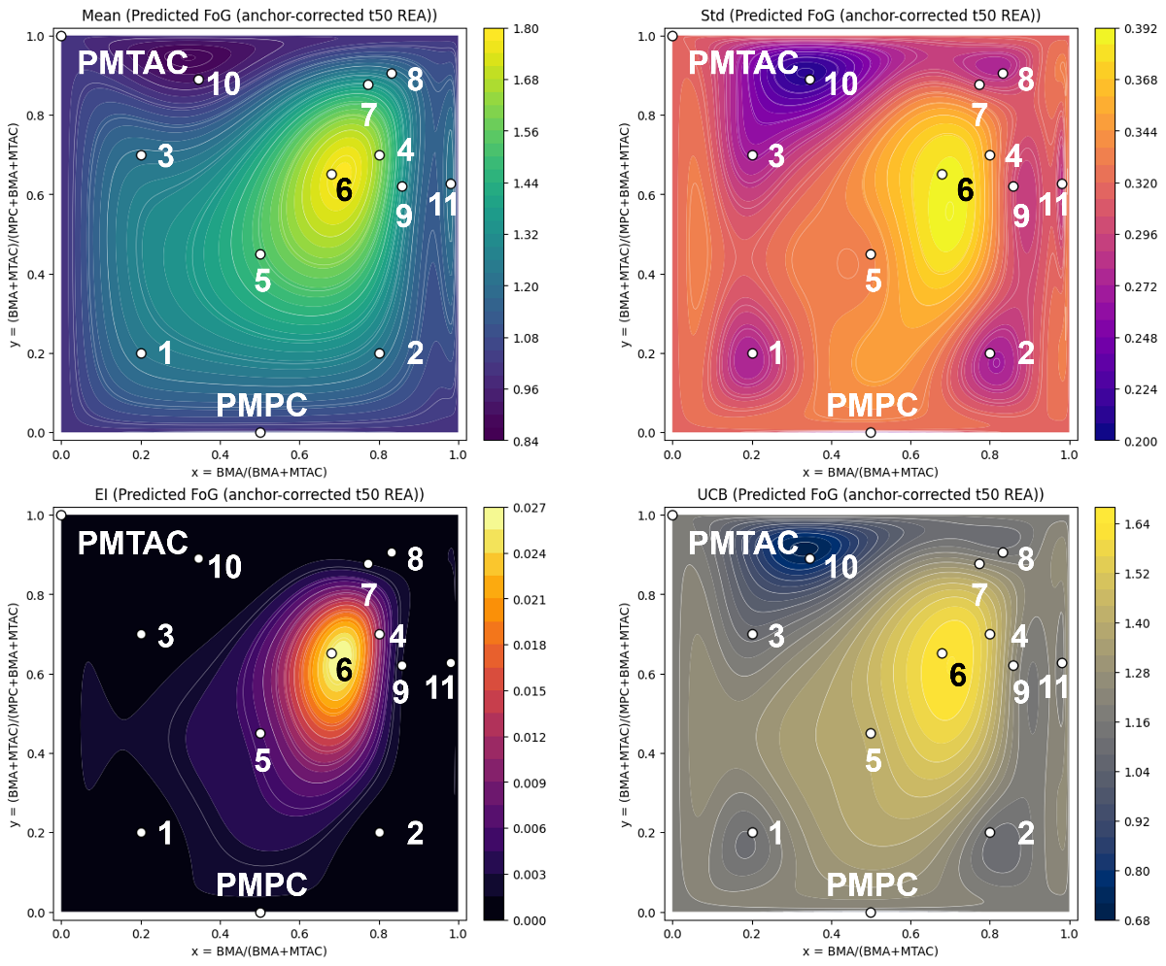

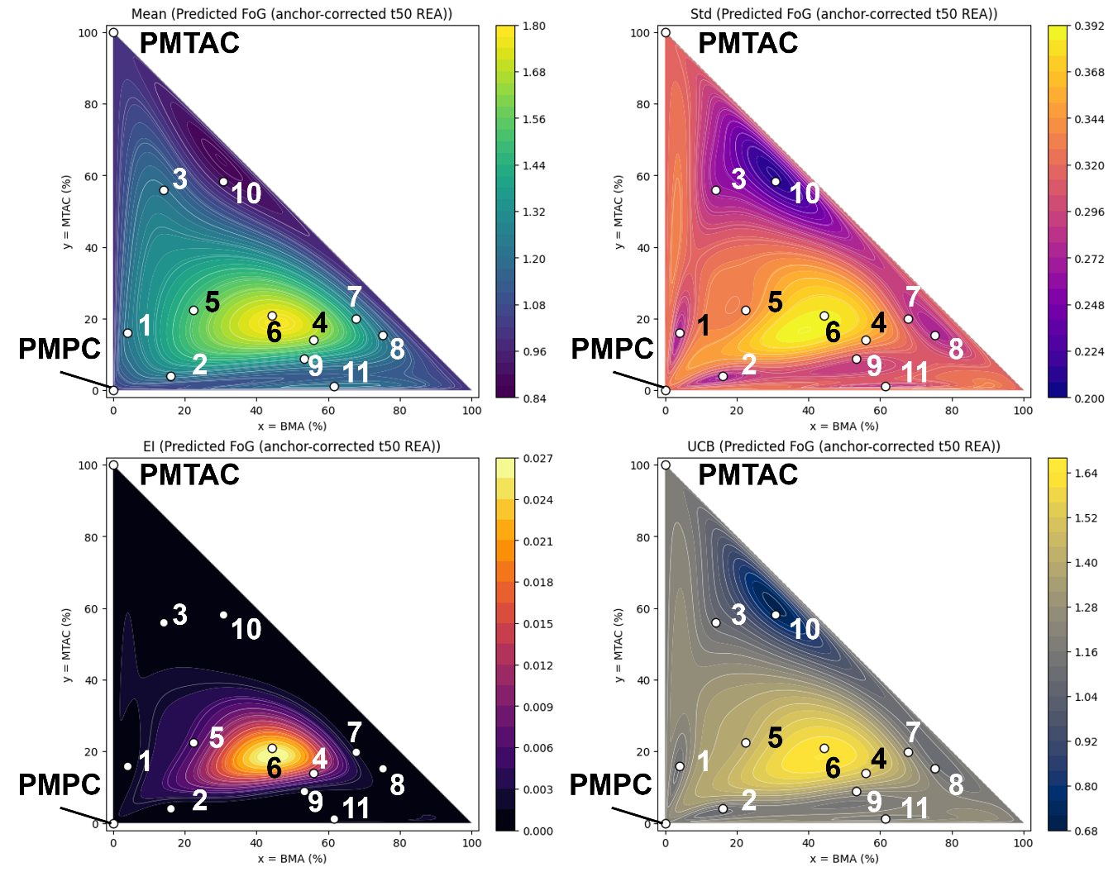

**Figure 20**. Bayesian surrogate and acquisition landscapes on the composition plane (Mean / Std / EI / UCB).

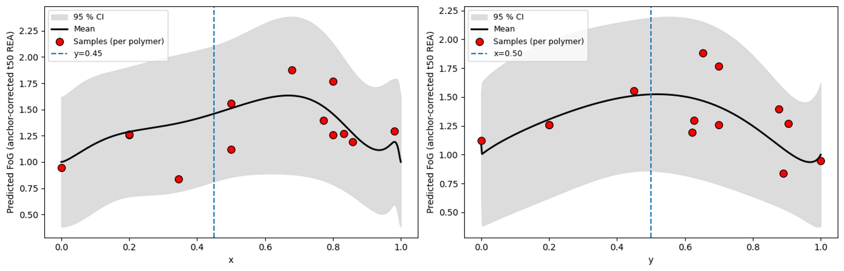

**Figure 21.** One-dimensional response profiles along composition axes (predictive mean with 95% CI).

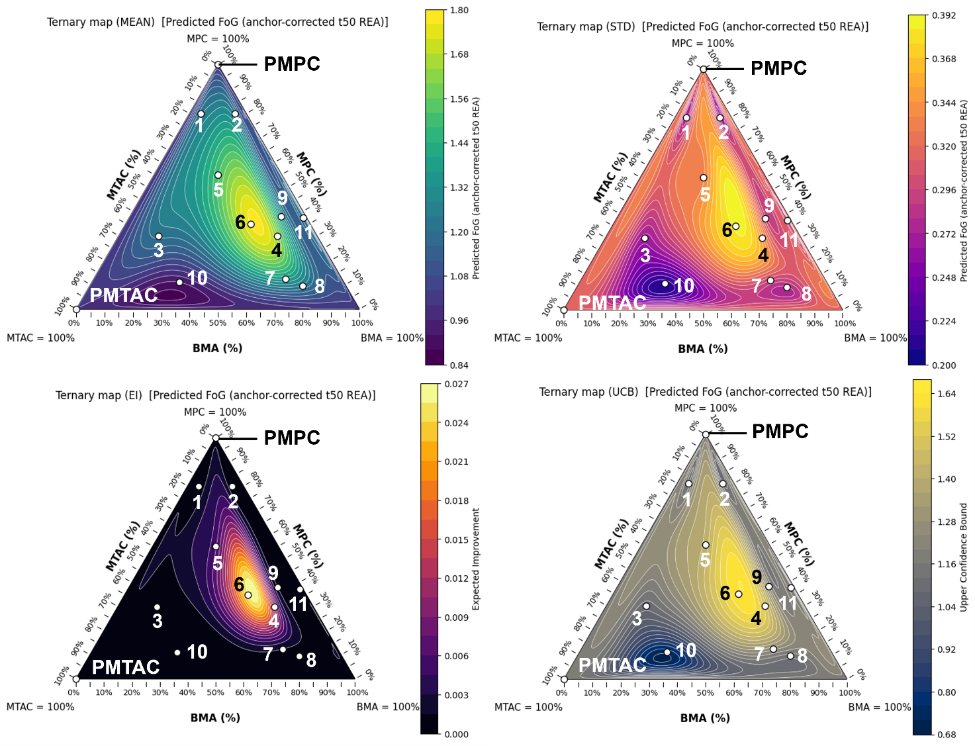

**Figure 22.** Ternary map of predicted performance across the MPC–MTAC–BMA space.

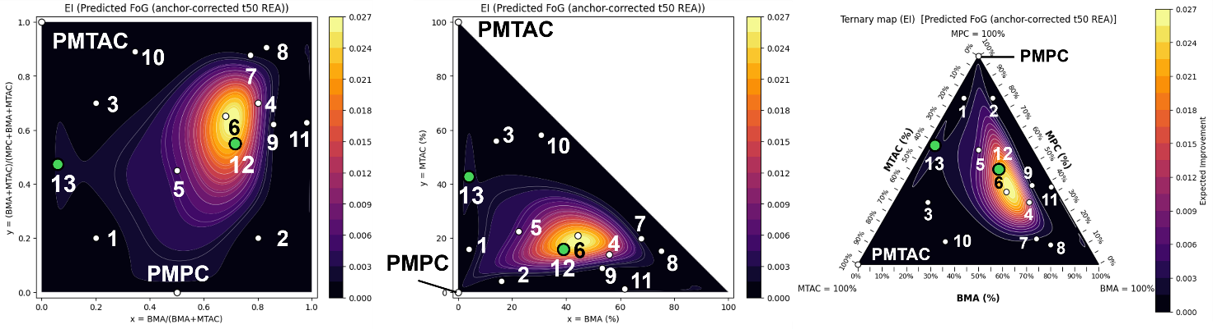

**Figure 23.** Mapping of candidates proposed by Bayesian optimization as having high EI

|  |  |  |  |  |  |
| --- | --- | --- | --- | --- | --- |
|  | $$x$$ | $$y$$ | **Feed Ratio (mol %)** | | |
|  | $$\frac{\left[BMA\right]}{\left[BMA\right]+ \left[MTAC\right]}$$ | $$\frac{\left[BMA\right]+ \left[MTAC\right]}{\left[MPC\right]+ \left[BMA\right]+ \left[MTAC\right]}$$ | **MPC** | **BMA** | **MTAC** |
| PMBTA-12 | 0.732 | 0.545 | 45.5 | 39.9 | 14.6 |
| PMBTA-13 | 0.087 | 0.460 | 54.0 | 4.0 | 42.0 |

1. **Future Plan**

* Synthesize the newly proposed copolymers PMBTA-12 and PMBTA-13.
* Evaluate the activity using β-D-galactosidase.
  + Consult regarding the purchase of the enzyme.
* Points to be investigated:
  + Introduce weight-averaged SHAP values based on the constituent homopolymers to clarify which molecular features contribute to enhanced thermal stability.
  + Define stopping criteria for each round of the Bayesian optimization.

1. **References**
2. Panganiban, B.; Qiao, B.; Jiang, T.; DelRe, C.; Obadia, M. M.; Nguyen, T. D.; Smith, A. A. A.; Hall, A.; Sit, I.; Crosby, M. G.; Dennis, P. B.; Drockenmuller, E.; Olvera de la Cruz, M.; Xu, T. Random Heteropolymers Preserve Protein Function in Foreign Environments. *Science* **2018**, 359, 1239–1243.
3. Tamasi, M. J.; Patel, R. A.; Borca, C. H.; Kosuri, S.; Mugnier, H.; Upadhya, R.; Murthy, N. S.; Webb, M. A.; Gormley, A. J. Machine Learning on a Robotic Platform for the Design of Polymer–Protein Hybrids. *Adv. Mater.* **2022**, 34, 2201809.
4. Nagao, M.; Nakahara, O.; Zhou, X.; Matsumoto, H.; Miura, Y. Bayesian Optimization of Glycopolymer Structures for the Interaction with Cholera Toxin B Subunit. *Nanoscale* **2024**, 12406-12410.